July 2020
SMART[4]: efficient and connected lighting
GEWISS has redesigned the Smart[4] LED range with higher-performance optical solutions that can connect to INTERACTIVE products, ideal for lighting every environment.
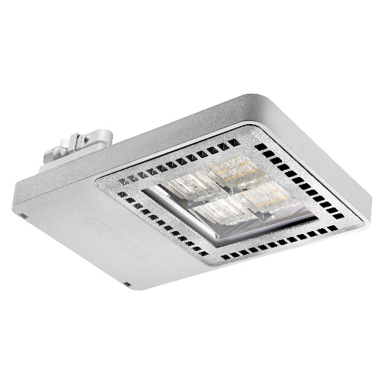
Smart[4] by GEWISS is the new range of lighting devices developed with the latest generation LEDs and new optical solutions, which guarantee excellent lighting performance, a significant increase in efficiency and unparalleled resistance, in every application context. The new Smart[4] devices can communicate with INTERACTIVE products, allowing any type of lighting system to become a smart system and facilitating easy, flexible and efficient management.
THREE SIZES, MULTIPLE VERSIONS, THOUSANDS OF APPLICATIONS
Smart[4] is a wide and flexible range, available in three sizes (1 module, 2 modules and 4 modules), with different colour temperature options (3000K, 4000K, 5700K), both in the HE (High Efficiency) and HLO (High Lumen Output) versions, both with an Emergency light option. Every device from the range is available with an On/Off or DALI 2 function, as well as Stand Alone or row installation with through wiring.
The Smart[4] | 1M Low Bay is ideal for internal lighting in sporting facilities (small gyms and pools), industrial warehouses and small logistics warehouses.
Smart[4] | 2M is suitable for lighting sports arenas, medium-height industrial warehouses and logistics departments.
Finally, the Smart[4] | 4M High Bay lends itself perfectly to lighting the interiors of large sports facilities, industrial warehouses, large depots and logistics departments.
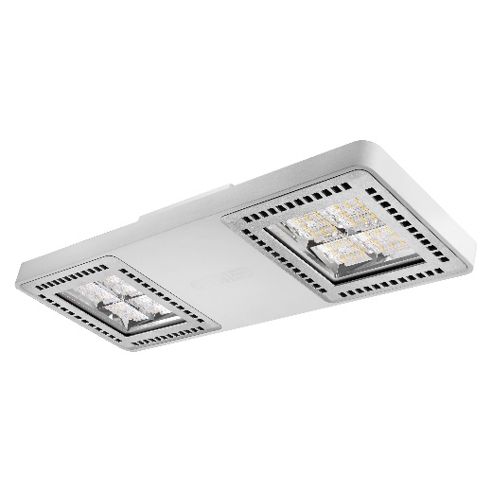
The range also includes ATEX and HT versions for installation in heavy duty environments, such as chemical and iron and steel industries, or HACCP versions for environments where hygiene conditions and protection are very important, such as the food industry.
HIGH PERFORMANCE FLEXIBILITY
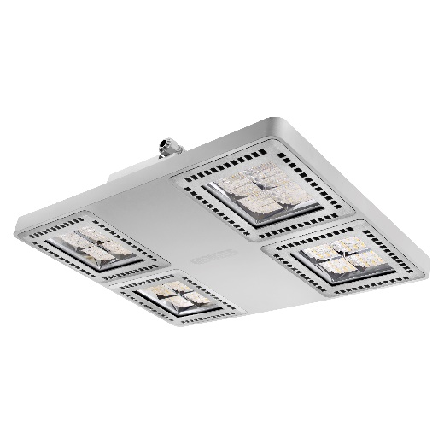
Smart [4] devices are designed to meet any type of lighting requirement, with a wide range of lenses and optical systems available. Utilising GEWISS' expertise in high-performance technopolymer moulding and the expert study of the optical laboratory, narrow (30°), medium (60°) and wide (90°) beam lenses have been designed for Smart[4], in addition to three types of light distributions, an elliptical, an asymmetric and a light-diffusing array. The wide variety of optics, combined with their high performance, facilitates a luminous flux of up to 36,400lm, for applications that require installation at a level over 10 metres.
SMART[4] AND INTERACTIVE: LIGHT BECOMES CONNECTED
The entire Smart[4] product range is able to communicate with INTERACTIVE systems, which allow the user to manage the various configurations in terms of switching on and adjusting, checking the status and configuring complex scenarios, all through a web interface or smartphone, even remotely. DALI versions can also interface with KNX and LORAWAN protocols, offering a complete Building Automation solution, which includes the integrated management of all IoT components.
SIMPLE MOUNTING AND RELAMPING
Every Smart[4] device is equipped with several mounting kits that can replace any type of fixture used in industrial environments, without having to modify the existing electrical and mechanical system. Most mounting kits are included with the product and do not need to be ordered separately, thus ensuring maximum flexibility, convenience and ease of installation.
Finally, with the careful selection of next generation LEDs, high-performance drivers and heat dissipation system design, GEWISS is able to guarantee the entire Smart[4] range for the highest quality, innovation of components and the end product for 5 years.
The Smart[4] range is part of GEWISS’ Endurance line, characterised by Flexibility, Modularity and Connectivity. Attributes that allow for perfect light management in every context, also in terms of the wellbeing of people, energy efficiency and reducing pollutant emissions. Core values, which transform a simple lighting fixture into a true Smart system.

