November 2020
ELIA: COMPROMISE-FREE LED SOLUTIONS FOR INDUSTRY
GEWISS presents the new range of lighting devices designed for the industrial sector, offering practicality, efficiency and low prices.
ELIA (the acronym of Easy Light & Installation Application) is the name of the new range of GEWISS LED devices designed for lighting manufacturing and logistics facilities, with the capacity to deliver energy efficiency and fast installation times, all with a moderate investment.
The range includes seven different types of solutions designed for use in every working area, from manufacturing departments to technical spaces and service rooms, and from offices to external areas such as façades, car parks and internal roads.
The main strengths of this range include ease of installation, fast return on investment and a 5 year GEWISS reliability guarantee. Furthermore, the ENEC community mark also certifies that these devices are compliant with European safety standards.
The range features 134 codes, and includes products of different powers and sizes, different colour temperatures and colour rendering indexes and accessories for the various types of assembly.
More specifically, the ELIA family of products is composed of:
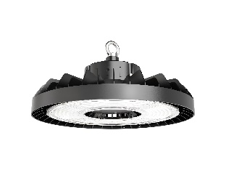
ELIA HL – Highbay Led. The ideal solution for general lighting in production spaces with high ceilings. Delivers excellent performance whilst providing energy savings, with low maintenance requirements.
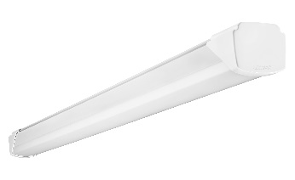
ELIA WL - Waterproof Led. A watertight luminaire with a compact design, feed-through wiring and excellent efficiency. The ideal solution for lighting manufacturing and logistics environments with lower ceilings.
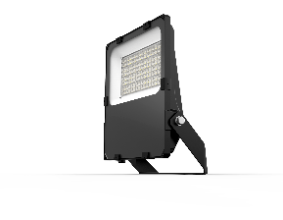
ELIA FL - Floodlight Led. The range of compact floodlights made from die-cast aluminium. Perfect for lighting outdoor areas and building façades, as well as car parks and internal roads. Combines quality lighting, energy savings and low maintenance requirements.
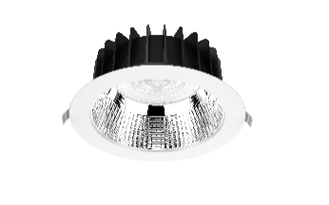
ELIA AL - Accent Led. Circular flush-mounting device for accent lighting in entrances, receptions and corridors. Flexible and suitable for a wide range of environments, it guarantees excellent energy savings with low maintenance.
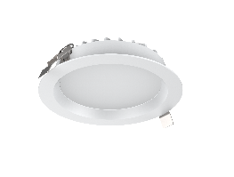
ELIA DL - Downlight Led. Circular flush-mounting device for general lighting, designed for meeting rooms, communal spaces or refreshment areas. Easy to install, it guarantees excellent energy savings, high flexibility and low maintenance.
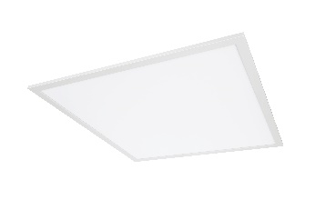
ELIA PL - Panel Led. Flush-mounting or ceiling-mounting luminaire device for offices and workplaces where glare and luminance control is required. Available in various versions for installation in all types of false ceilings, this device is the ideal solution for replacing old lighting systems with traditional light sources, boosting the efficiency of the system.
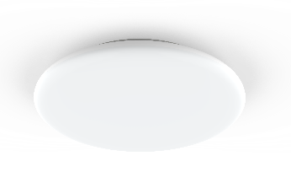
ELIA CL - Ceiling Led. Circular surface ceiling or surface-mounted device designed for lighting service areas, bathrooms and stairways. Crafted entirely from polycarbonate, it is easy to install and requires almost no maintenance. An easy device with a simple, discreet design.

ELIA is a simple, quick to install solution which can improve efficiency and energy consumption in production areas and spaces in small and medium industrial companies. No compromises.

