November 2016
ROAD [5], FIRST-CLASS PERFORMANCE ON EVERY ROAD
The new GEWISS range of LED devices for lighting streets and residential areas.
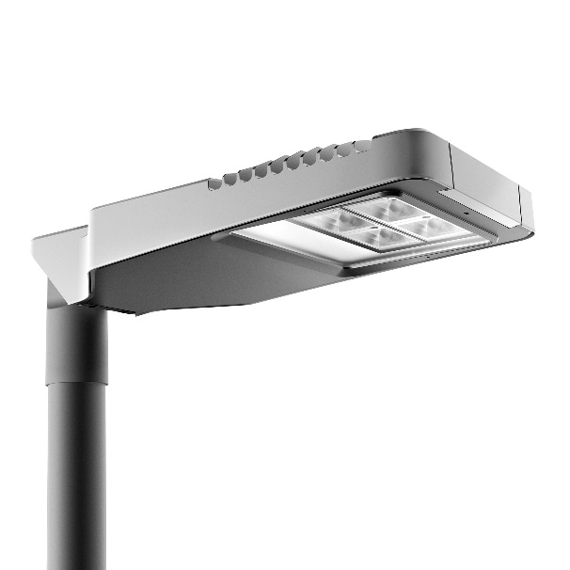
Road [5] is the new range of LED lighting devices that completes the selection for street and urban applications. This new line is designed to offer the best inter-distance / height ratio, simplify device installation and maintenance, and favour high energy savings.
Road [5] is the ideal solution for lighting every type of urban and extra-urban roads, roundabouts, large outdoor areas and car parks. The compact design and limited dimensions of the lighting body make a discreet, well-balanced addition to all urban centres, from the major metropolis to the small town. The different types of road in the urban and extra-urban contexts require different forms of light distribution. Road [5] has two types of optic to meet every installation need.
The wiring can be carried out with the device already fixed in place (opening it without using any tools), which means notably reduced installation times and extremely safe operations. To optimise the operating costs, Road [5] range is designed to house all the main remote management devices, adapting to existing or preferred central systems (power line communication or Wi-Fi).
MAIN CHARACTERISTICS
- IP66 DEGREE OF PROTECTION. Both the optical compartment and the whole device provide an IP66 degree of protection, ensuring correct operation in all conditions.
- THREE SIZES, JUST ONE DESIGN. The minimalist geometries of Road [5] come in three different sizes to guarantee the best lighting for traffic on every type of urban and extra-urban road.
- LIGHTWEIGHT AND PRACTICAL. The limited weight and tool-free opening system of the new GEWISS devices make all installation and maintenance work easier, smoother and faster for the experts.
- INTELLIGENT LIGHT MANAGEMENT. The suitably proportioned electric unit compartment (in the three sizes of Road [5]) makes it possible to fit devices for intelligent light management inside the light body.
- DIFFERENT POWER SUPPLY CURRENTS. Road [5] can be supplied with different power supply currents for the LEDs, to suit any type of application.
- ADDITIONAL SHIELD. The device has holes for fitting additional shields for back-light resolution and low heights, or poles with double side bracket.
- LIFESPAN AND OPERATING TEMPERATURE. Road [5] guarantees an operating lifespan of at least 70,000 hours (L80) in standard conditions (from -25°C to 40°C).
- LIGHT SHIELDING. The shielding angle for low height installation reduces disturbance and light dispersal when located near cycle paths or private homes.
- DEVICE IN CLASSES I AND II. The device is supplied as standard in Class II, but Class I is also available upon request.

