November 2016
CHORUS ICE, THE NEW STYLE OF DOMOTICS
GEWISS presents its new range of Chorus ICE plates: sophistication and technology - bringing out the best in lighting devices.
Chorus ICE is the new range of GEWISS plates, combining luxury and technology. Made of glass and available in three different colours (white, black and titanium), the plates of the ICE family meet the most sophisticated technological and design requirements and represent a new frontier for the lighting device. The new ICE Chorus devices offer an entirely new sensory experience: a perfect alchemy that brings together the purity of glass, the delicacy of the touch commands, and the elegance of the illuminated symbols.
The ICE range comprises three versions - ideal for the different needs of electrical systems (conventional and domotic systems) and for the styles of any interior: ICE, for conventional command devices; ICE Touch and ICE Touch KNX, for touch command modules or Touch KNX push-button panel modules.
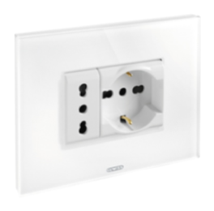
Chorus ICE
ICE plates can be used with all Chorus range modular devices, including commands, systems for power take-off, protection and signalling, comfort, climate control and technical alarms. ICE can deliver solutions for all situations. Available with 3 or 4 gangs, the ICE range of plates combines the pure luxury of glass with the sleek sophistication of conventional controls.
Chorus ICE Touch and ICE Touch KNX
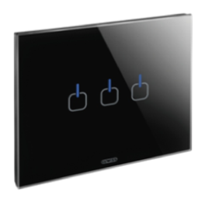
ICE Touch and ICE Touch KNX plates - just one touch for all your needs in the home. The pureness of white, the functionality of titanium and sophistication of black are all enhanced by the elegant symbols on the plate, which light up when selected, for a stunning solution.
The innovative Touch controls turn the lighting device into a multi-sensory experience. ICE Touch offers so much more than just a tactile experience: the multicoloured backlit display attracts the attention, while the acoustic feedback is easy on the ears.
The ICE Touch plates are available in versions with 1, 2 and 3 symbols, using the same supports and flush-mounting boxes as conventional plates. The three flush-mounting devices (one-way switch, dimmer and command repeater) provide all the basic functions for an outstanding level of comfort in the home. Plus the 2, 4 and 6 symbol push-button panels (in the KNX version) give ICE Touch an elegant interface for domotics. If required, the localisation LED and acoustic signalling can be enabled or disabled and the touch sensitivity level (only for KNX versions) can also be modified.

