November 2016
A NEW HEART FOR THE INDUSTRIAL CONNECTION SYSTEM
GEWISS renews its industrial connection system, introducing the new range of IEC309 HIGH PERFORMANCE socket-outlets and plugs.
GEWISS's new IEC 309 HIGH PERFORMANCE range is a high-end range of industrial connections delivering an outstanding performance, functionality and technical features. The range boasts a fully comprehensive assortment of products to create any kind of service or industrial system and make installation even simpler and easier.
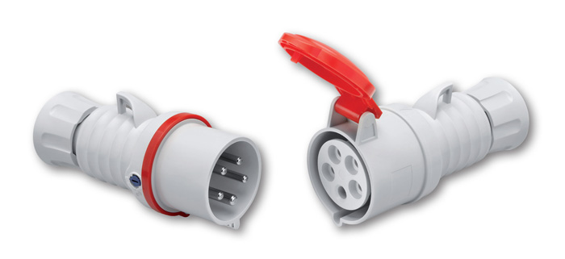
The new range expands GEWISS's assortment of 16 A and 32 A mobile plugs, mobile and flush-mounting socket-outlets, with IP44 and IP66/67/68/69 degree of protection, both in the quick and screw wiring versions.
The introduction of all time references of the earthing contact completes the range of possible applications, with specific versions for more rigid and complex installations. The range is extremely quick and simple to assemble and wire - a unique feature on the market. The range has also been restyled as a single modern, functional line, for both quick and screw wiring versions.
Besides the new HIGH PERFORMANCE, the range includes 63 and 125 A plugs and socket-outs, with a polarity, voltages and nominal frequencies suitable for all systems up to 500V, in IP44 protected and IP67 watertight versions, multipliers and adapters, very low voltage versions, plus 90°, straight flush-mounting and 10° surface-mounting versions.
Main features of the IEC 309 High Performance range
SAFE-LOCK CLOSURE. The ¼ turn screw guarantees practical, simple use, quick assembly and safe closing thanks to the readily identifiable reference system; plus the same blade screwdriver used for conventional wiring can be adopted. The reinforced technopolymer of the SAFE-LOCK system ensures maximum resistance to abrasion and a long life, eliminating the problem of metal closing system corrosion, even in more aggressive environments. The body/grip coupling is solid and effective for an outstanding performance.
PRACTICAL AND ERGONOMIC. All the mobile socket-outlet covers have a special shape making them safe and simple to open. So the covers can be opened using just one hand: this makes plug/socket-outlet insertion practical and simple.
A NEW FUNCTIONAL COUPLING SYSTEM. The nibbed screw, which is a product requirement for secure socket-outlet covers, is also on the socket-outlets. With their innovative shape, these new products can be coupled to fencing and scaffolding during use in trailing systems.
RAISED EARTH TERMINAL. The new IEC309 HIGH PROTECTION range has an earth terminal that is raised compared to other terminals. If a connection cable is accidentally pulled out, the earth cable will be the last to be released, preventing the user from getting an electric shock and avoiding electrical discharge on devices.
A NEW CABLE CLAMPING SYSTEM. The new external cable clamp, used on all versions, secures the cable and maintains the IP rating in absolute safety. It can easily be bundle closed by hand, without using any tools. The anti-loosening device prevents the accidental unscrewing or loosening of screws, even when subject to considerable vibration or mechanical stress. The ring nut is unlosable, even if completely loose, to make wiring easier for the installer. The cable gland can accommodate a range of cables above regulatory requirements, both at the bottom and top.
NICKEL-PLATED PINS AND CONTACTS. All IEC309 HP range products feature nickel-plated pins and contacts for a more efficient contact on elements subject to a higher degree of oxidisation: the nickel-plating guarantees maximum product life and allows for use in environments with critical climatic conditions (marine environments) or aggressive substances.
SINGLE PACK. Each IEC 309 HP range item is individually blister-packed. This means the product is always clean in all storage conditions. Each blister pack has the bar code of the product, for easy identification by wholesalers and the instructions leaflet.
HALOGEN-FREE. All products are in halogen-free technopolymer conforming to EN50267-2-2, guaranteeing the utmost safety for people and equipment in the case of fire: the ideal and most common solution throughout Europe for all public places and areas with large numbers of people.

