November 2016
DESIGN SOLUTIONS FOR SYSTEM CENTRALISATION
GEWISS presents DOMO CENTER, the innovative system column with a modern and refined design that blends the home automation system into the décor of your home.
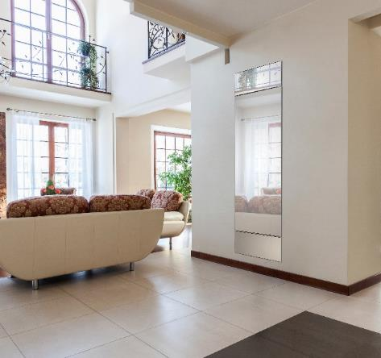
GEWISS has created DOMO CENTER, the innovative system column that integrates devices for energy distribution, domotics, multimedia and safety.
With a high level of modular capacity, excellent aesthetic integration with all indoor furnishings, a protrusion of only 25 mm: DOMO CENTER defines a new standard for the centralisation and rationalisation of the electrical system. Innovative solutions to facilitate the integration of both advanced and traditional services in one single product.
The attention to style, combined with elements of design customisation, make DOMO CENTER a unique product that adds a touch of personality, modernity and technology to every residential and commercial context.
DOMO CENTER is available in two different heights, 210 e 240 cm, and in multiple versions, all characterized by the exclusive "suspended effect" on the wall. From the elegant mirror finish to the the version with panel for domotic control and supervision, from the configuration without door to those with integral glass door.
DOMO CENTER offers versatile solutions that can be configured to suit the context and the specific needs, fulfilling different functions: column for the home, general column for the whole floor of a building or column for uprights. The lines and customised finishes of DOMO CENTER combine perfectly with the design of the CHORUS domestic range: a style continuity that makes DOMO CENTER a solution able to blend with the existing room.
Ease of installation, modern, elegant and refined design: DOMO CENTER blends the domestic management system into the décor of your home.

