November 2016
THE 44CE RANGE, GREAT SOLUTIONS FOR SYSTEMS
GEWISS presents its new junction boxes with high capacity back-mounting box for the wiring requirements of sophisticated electrical systems.
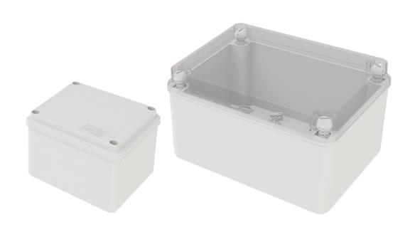
GEWISS has produced the new 44 CE range of boxes with high capacity back-mounting box designed to meet market trends that call for greater space for wiring, because of the high level of electrification of new systems; the large number of electric lines requires bigger diameter conduits and capacious junction boxes.
These specific characteristics have steered the design and development of a new range of boxes, with each detail conceived to make installation, use and application even easier. These guidelines have led to the development of particularly robust boxes even without ribs on the inner vertical walls and special functional ribs on the back-mounting box enabling the fixing of plates, DIN rails and terminal blocks. The boxes can be used to easily couple large diameter conduits (up to 50 mm ø) without any interference with multiple accessories as the set back ribs do not interfere with the inner ring nuts of the conduit/box couplings.
In the two largest sizes, apart from the classic assembly solutions using fixing brackets and a screw or wall plug (in all the versions), there are also special seats on the back-mounting box for quick fixing using a riveter. The covers have spherical plastic fixing screws for a hinged opening and the size 8 back-mounting box means back-mounting plates, of even smaller sizes, can be assembled.
The dimensions range from 100 x 100 with a height of 80 mm, up to 380 x 300 with a height of 170 mm; available with both a blank and see-through lid, these features and the all-round synergy with accessories of the range make the 44CE range stand out even more.
Made of top quality, halogen-free technopolymers, the new boxes guarantee a self-extinguishing degree equal to GWT 650°C and IP56 degree of protection. These characteristics allow the 44 CE boxes to be used in any indoor or outdoor environment, even those with a notable fire risk.

